**Parent** *I* **Teacher Meetings**

Parent Teacher Meetings are being held on Wednesday, October 29th from 3:30pm - 5:00pm and 5:30pm - 7:00pm at Vic High (1260 Grant Street) throughout the first floor hallway and communal spaces. Meetings are booked online using Microsoft Booking. Parents and guardians are able to easily access the system and **book appointments from Monday, October 20th at 4:00 pm to Monday, October 27th at noon on a first come first served basis.** You will need the names of the teachers that you would like to meet with (please review your student’s teacher’s names on their schedule through [Parent Connect](https://parentconnect.sd61.bc.ca/Identity/Account/Login?ReturnUrl=%2F) or ask your student for their teachers' names).

*How to book Parent I Teacher Interview appointments:*

1. Click Parent/ Teacher Meetings under 'Quick Links' on the Vic High website [(https://vichigh.sd61.bc.ca/)](https://vichigh.sd61.bc.ca/)

1. Booking an appointment using **Microsoft Bookings:** <https://outlook.office365.com/owa/calendar/VictoriaHighSchool@gvsd61.onmicrosoft.com/bookings/>
   1. Select a **'Service'** (Victoria High Teachers A-G or H-M or 0-Z)
   2. Select the correct date from the **Calendar (October 29)**
   3. Choose your child's teacher from **Select Staff**
   4. Choose a meeting time from the available options. If a time is not available it has already been booked. If all time slots are filled, please email the teacher directly to make alternate arrangements.

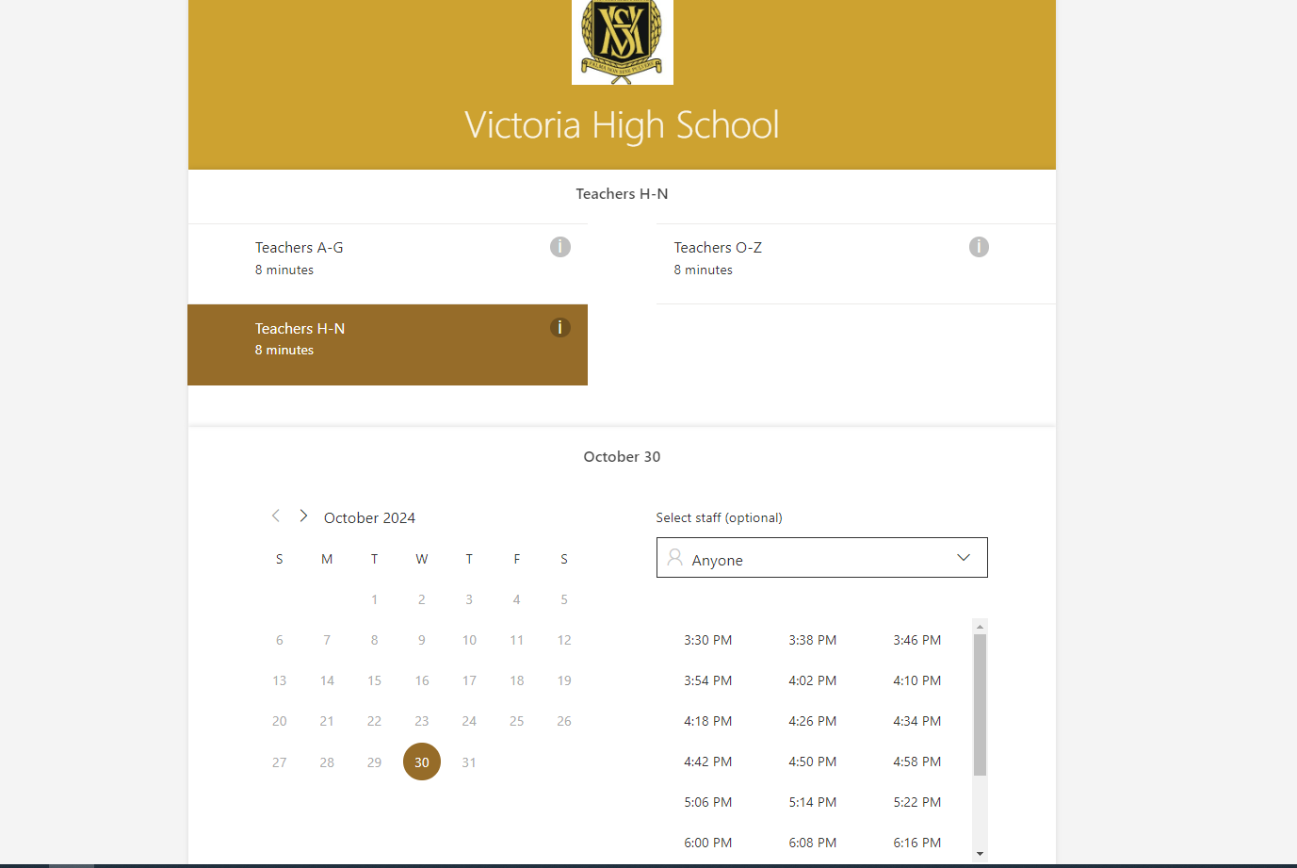

Select a service from the list (according to the teacher’s last name)   
  
(A-G or H-M or N-Z)

Choose a meeting time from the available options. If a meeting time is not available, it has already been booked.

Select the date determined by your school for parent teacher meetings

Choose your student’s teacher from the drop down menu

* 1. Under **Add Your Details,** enter parent name, email address and phone number.
     1. Under notes, please enter any additional notes you would like to message to your child's teacher (Optional)  
        A screenshot of a computer

        Description automatically generated

After you’ve confirmed you’ve selected your child’s teacher, please select Book to complete the booking

Please enter   
  
Your name (as parent guardian)

&

Your student’s name

Enter your name, email address and phone number

Please enter any additional notes you would like to message to your student’s teacher

* 1. When all information is added, click **Book** to complete your booking